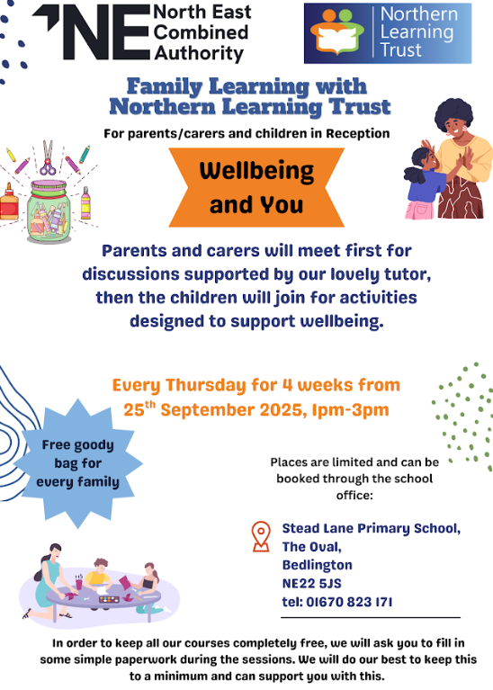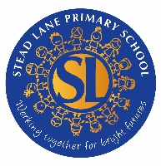

Wellbeing and You

These fun sessions for our Reception children and their families will be held in our school. If you would like to sign up please complete the attached reply slip and return it to school asap as spaces are limited. We hope to see you there!

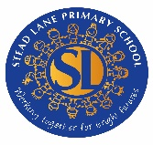-------✂-------------------------------

We would like a place on the Wellbeing and You sessions beginning on 25th September at 1pm.

Signed: ___________

Parent/Carer of:______________