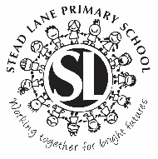
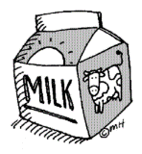
STEAD LANE PRIMARY SCHOOL

MILK

The cost of milk for the Autumn Term is £13.00

If you wish your child to have milk and they are in main school (Nursery do not need to complete a form), would you please return the attached Milk Order Form to us as soon as possible. Milk orders are placed on Wednesday mornings so if you return this form later than Tuesday 15th July 2025 your child will not receive milk on the first day of term in September.

Water will be available for those children who do not have milk.

Free Milk * Nursery children will continue to receive free milk.
* Those children in Main School who will remain under 5 years old until the end of the Autumn Term (19th December 2025) will continue to receive free milk.

* Children who are entitled to income based Free School Meals.

For those paying for milk - milk money is due with the Milk Order Form - no milk will be ordered unless money is enclosed.

If your child is in main school, whether they are entitled to free milk or not - please make sure that you fill in a milk order form if you wish them to have milk.

Online orders must also be completed below as we do not receive instant confirmation of your payment so milk may not be ordered if we don’t receive your order form.

- - - - - - - " - - - - - - - - - - - - - - - - - - - - - - - - - - - - - - - - - - - - - - - - - - - - - - - - - - - - - - - - - - - - - -

STEAD LANE PRIMARY SCHOOL

MILK ORDER FORM – AUTUMN TERM 2025

Reply Slip:

My child will require milk, I enclose £13.00 
My child will require milk, I have paid £13.00 online 
My child will require milk and is entitled to income based Free School Meals 
My child will be under 5 years until the end of term (19th December 2025)
so is therefore entitled to free milk (D.O.B.______/_______/______) 

Signed: ________________________Parent/Carer

Name(s) of child(ren): ___ __________________________________________________

Classes:______________________________________

