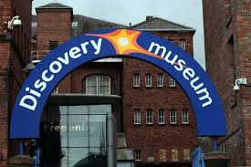
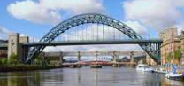

STEAD LANE PRIMARY SCHOOL

YEAR 4 VISIT TO NEWCASTLE

February 2024
Dear Parents/Carers,

We have organised a visit to Newcastle on Thursday 21st March 2024 for Year 4. During the visit the children will walk along the quayside looking at the modern aspects of the River Tyne then make their way to the Discovery Museum to take part in a workshop looking at the history of the River Tyne and what jobs there were on the river (shipyards etc.)

All children will need a packed lunch on this day which is available from school , please see below, but our kitchen staff must have your child’s order in advance please.

Any child who suffers from travel sickness must take medication before leaving home in the morning.

School uniform must be worn on this day as we may not be the only school attending the Museum.

During your child’s time at Stead Lane they will take part in some visits paid for in full by yourselves and some subsidised by school. On this occasion we ask that you make a contribution of £5.00 per child please.

If we do not hold a Parental Consent Form for your child, one will be attached to this form for you to complete and return please. If there is no form attached then we already have consent which covers this event but if there are any new medical needs or information which we need to know about please contact a member of staff as soon as possible.

Please complete and return the attached slip to school as soon as possible.

Thank you.

E. Leybourne
Year 4 Teacher
- - - - - - - - - - - - - " - - - - - - - - - - - - - - - - - - - - - - - - - - - - - - - - - - - - - - - - - - - - - - - - - - - - - - - - - - - - - - - - - - - - - - - - -
STEAD LANE PRIMARY SCHOOL

YEAR 4 VISIT TO NEWCASTLE

Name of Child:_________________________________________________________
I enclose £5.00 towards the cost of the outing £
I will make my payment online £

I will supply a packed lunch from home £
I would like my child to receive a packed lunch from school as he/she is on free school meals (please complete below) £
I would like my child to receive a school packed lunch and I will send £2.30 into school (please complete below) £

Please choose from the following for your packed lunch on your trip:
Sandwich filling:
Ham □
Cheese □ Tuna Savoury □

Do you want your sandwich in:
Bread □ Wrap □

Do you want salad on your sandwich? YES/NO *(please delete)

